TYPE OF CONTAINER |  | INTERIOR DIMENSIONS (MM) | DOOR OPENING (MM) | LOAD CAPACITY (CU-M) | MAX-PAYLOAD (KG) | TARE (KG) | MAX-GROSS (KG)
20 FT DRY CONTAINER | 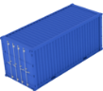 | L:5880-5895  W:2330-2350  H:2380-2390 | W:2330-2340  H:2275-2280 | 33-33,2 | 21000-28000 | 2200 | 30200
40 FT DRY CONTAINER | 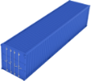 | L:12024-12032  W:2330-2350  H:2380-2390 | W:2330  H:2275-2280 | 67-67,7 | 26580-28840 | 3660-3900 | 30480-32500
40 FT HIGH CUBE DRY CONTAINER |  | L:12032  2330-2350  H:2680-2695 | W:2330-2340  H:2585-2583 | 76-76,4 | 26400-28660 | 3840-4200 | 30480-32500
20 FT OPEN TOP CONTAINER | 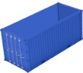 | L:5880-5897  W:2330-2350  H:2329-2350 | ROOF OPENING  W:2200-2230  L:5396-5757 | 32-32,8 | 21800-28130 | 2350-2400 | 30480-30530
40 FT OPEN TOP CONTAINER | 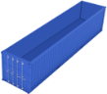 | L:12007-12030  W:2330-2350  H:2329-2367 | ROOF OPENING  W:2190  L:11500-11871 | 65,3-66,9 | 26330-26680 | 4150 | 30480
20 FT FLAT RACK CONTAINER | 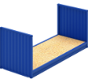 | L:5700-5900  W:2335-2350  H:2250-2276 |  | 25-29,45 | 21280 | 2720 | 24000
40 FT FLAT RACK CONTAINER | 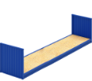 | L:11700-11980  W:2378  H:1960 |  | 56,6 | 39000-45000 | 4320-5000 | 45000-50000
40 FT PLATFORM CONTAINER | 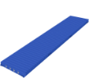 | L:11700-11980  W:2380  H:1955 |  | 56,6 | 39000-45000 | 4320-5000 | 45000-50000
40 FT HIGH CUBE REEFER CONTAINER | 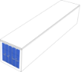 | L:11590 W:2290  H:2544-2547  MLH:2400 | W:2290-2294  H:2569 | 67,3-67,7 | 29280-29390 | invl.:4600-4720  excl.:4160-4190 | 34000
20 FT ISO TANK | 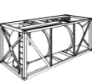 | – | – | – | – | – | –
40 FT PALLET WIDE |  | L:12095  W:2422  H:2387 | W:2395-2400  H:2274-2279 | 69,9 | 30010 | 3990 | 34000
45 FEET HIGH CUBE PALLET WIDE |  | L:13532  W:2426  H:2694 | W:2363-2410  H:2500-2584 | 89 | 29740 | 4260 | 34000

